

**Project Report**

Project Name: **Online Based Medicine Trading**

Course Name: CSE311

Section: 4

**Group Members**

|  |  |
| --- | --- |
| Name | ID |
| Mynur Rahman | 1711021642 |
| Sanjida Ahmed | 1711951642 |

**Project Description:**

This project is developed to serve 24/7 medicine supply for the patient. This is achieved via web technologies. We created a website where the owner of the website can offer various medicine to the patient. The patient can search medicine and add the medicine to the cart. The patient can also choose the quantity of the medicine. Finally, the patient has to enter his/her name and delivery address and also has to upload image of the prescription and after that they can place order.

**Used languages/framework:**

Front End: HTML, Bootstrap 4

Backend: MySQL and PHP

**Database design:**

We created 2 table to store data. First table name is product. The schema is given below

CREATE TABLE Product (  
    product_id int NOT NULL AUTO_INCREMENT,  
    product_name varchar(255) NOT NULL,  
    product_info varchar(1000),  
    product_price int,

manufacture_date date,

expire_date date,  
    PRIMARY KEY (product_id)  
);

The second table is orderdetails. The schema is given below

CREATE TABLE orderdetails (  
    order_id int NOT NULL AUTO_INCREMENT,  
    product_name varchar(1000) NOT NULL,  
    customer_name varchar(50) NOT NULL,  
    product_quantity varchar(1000),

Total_price int,

delivery_address varchar(225),

file_name varchar(225),

PRIMARY KEY (order_id)

);

**ER diagram:**

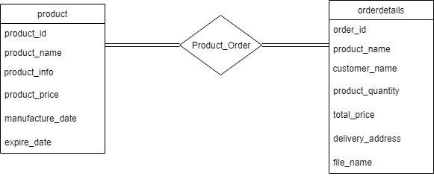

**Used Query:**

This query is used to insert product details in the product table:

INSERT INTO product(product_name, product_info, product_price,manufacture_date, expire_date)

VALUES

("Product Name","Product Info", Price ,'DATE','DATE'),

("Product Name","Product Info", Price ,'DATE','DATE'),

("Product Name","Product Info", Price ,'DATE','DATE');

This query is used to insert order details in the orderdetails table:

INSERT INTO

orderdetails

(product_name, customer_name, product_quantity, total_price, delivery_address, file name)

VALUES

("Product name","Customer name","Quantity", Price, "address",” file name”),

("Product name","Customer name","Quantity", Price, "address",” file name”),

("Product name","Customer name","Quantity", Price, "address",” file name”);

This query is used to show all available products:

SELECT * FROM product;

This query is used to show searched product:

SELECT * FROM product WHERE product_name LIKE ‘%keyword%’;

**Backend details:**

We created 3 webpages for using PHP and HTML. All the authentication is done using php. The webpage index.php which shows all the available products in a table. The user can enter the quantity and add product to cart. The user can also see the cart in the navbar.

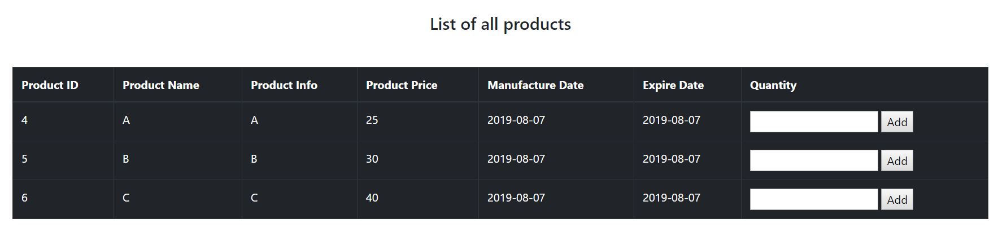

Image of product table

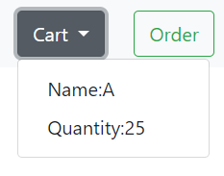

Image of navbar cart

The search page also shows the searched products in a table and user can also add medicine to the cart. And after that user can go to the order page where he/she can see cart details and total price. The user needs to add name, address and prescription image. After that the user can confirm order.

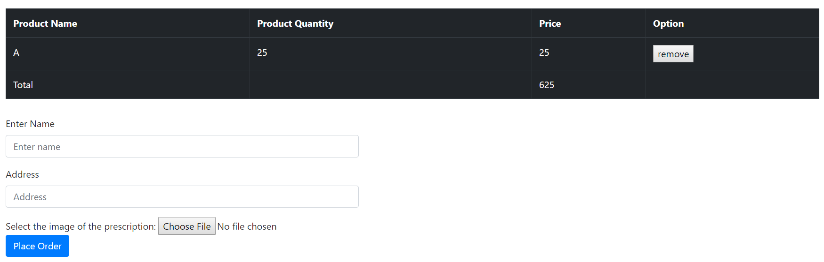

We also created a dbmanager.php which holds a dbmanager class. This class handles all the database query. The class diagram is given below:

|  |
| --- |
| dbmanager |
| dbconnection(); //Creates connection to database  selectAll($con); //Selects all available product details  search($con,$name); //Selects searched product details  insertOrder($con,$productName,$customerName,$productQuantity,$totalPrice,$address,$fileName);  // Saves order details |

**Conclusion:**

This project is still at its beginning stage. If we develop this project in a larger scale it can serve its purpose even better. If we can add customer account and admin account and better search options then this project can be used to help millions of customers online.